ERD IN CLASS EXAMPLES

Business rules (i.e., relationships)

Example 1

- a professor teaches zero, one or many classes and a class is taught by one professor. a course may generate zero, one or many classes and a class comes from one course. a class is held in one room but a room has many classes.
- Each Company operates four departments, and each department belongs to one company. Each department employs one or more employees, and each employee works for one department. Each of the employees may or may not have one or more dependents, and each dependant belongs to one employee. Each employee may or may not have an employment history.
- The video rental company has several branches throughout the Pakistan. The data held on each branch is the branch address made up of street, city, and zip code, and the telephone number. Each branch is given a branch number, which is unique throughout the company. Each branch is allocated staff. The data held on a member of staff is his or her name, position and salary. Each member of staff is given a staff number, which is unique throughout the company. Each branch has a stock of videos. The data held on a video is the catalog number, video number, title, category, daily rental, cost, status, and the names of the main actors and the director. The catalog number uniquely identifies each video. However, in most cases, there are several copies of each video at a branch, and the individual copies are identified using the video number. Before renting a video form the company, a customer must first register as a member of registered at a branch. Each member is given a member number, which is unique throughout all branches of the company. Once registered, a member is free to rent videos, up to maximum of ten at any one time. The data held on each video rented is the rental number, the full name and number of the member, the video number, title, and daily rental, and the dates the video is rented out and returned. The rental number is unique throughout the company.
- an invoice is written by one salesrep but a salesrep writes many invoices. a vendor sells many products but a product is bought from one vendor. an invoice has one or many products and a product is found on zero, one or many invoices

Example-1 Solution (Incomplete)

The many-to-many relationship is not resolved, therefore the solution is incomplete. In the final solution the many-to-many must always be resolved.

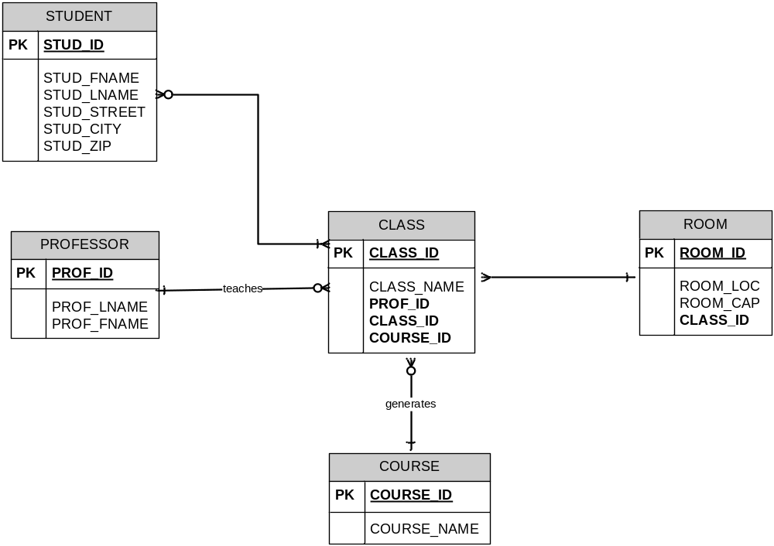

Final Solution (Complete)

In this example, the many-to-many relationship between student and class is resolved.

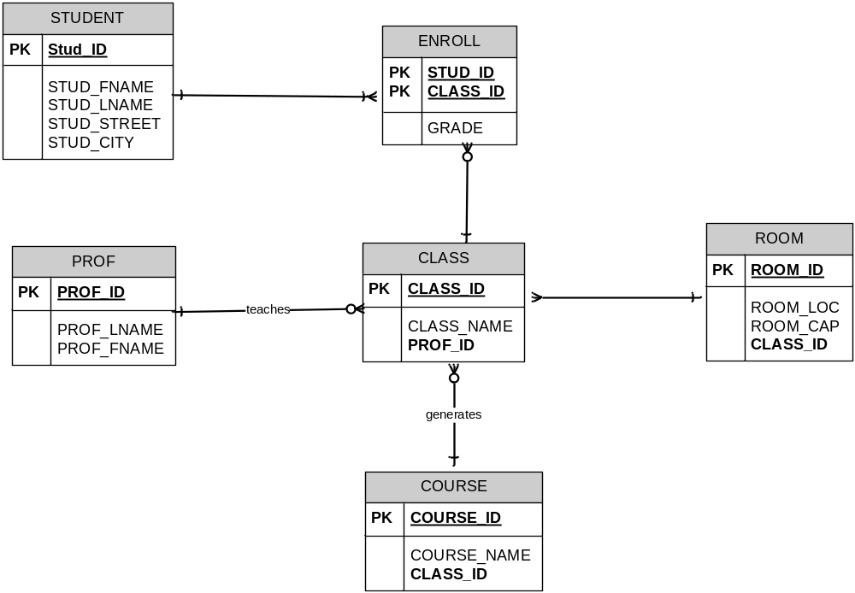

Solution to the INVOICE problem

